Title
DLL_Surface_Cpp_ReliefTypeDiffractiveSurface

Author
Csilla Timar-Fulep

Brief Description
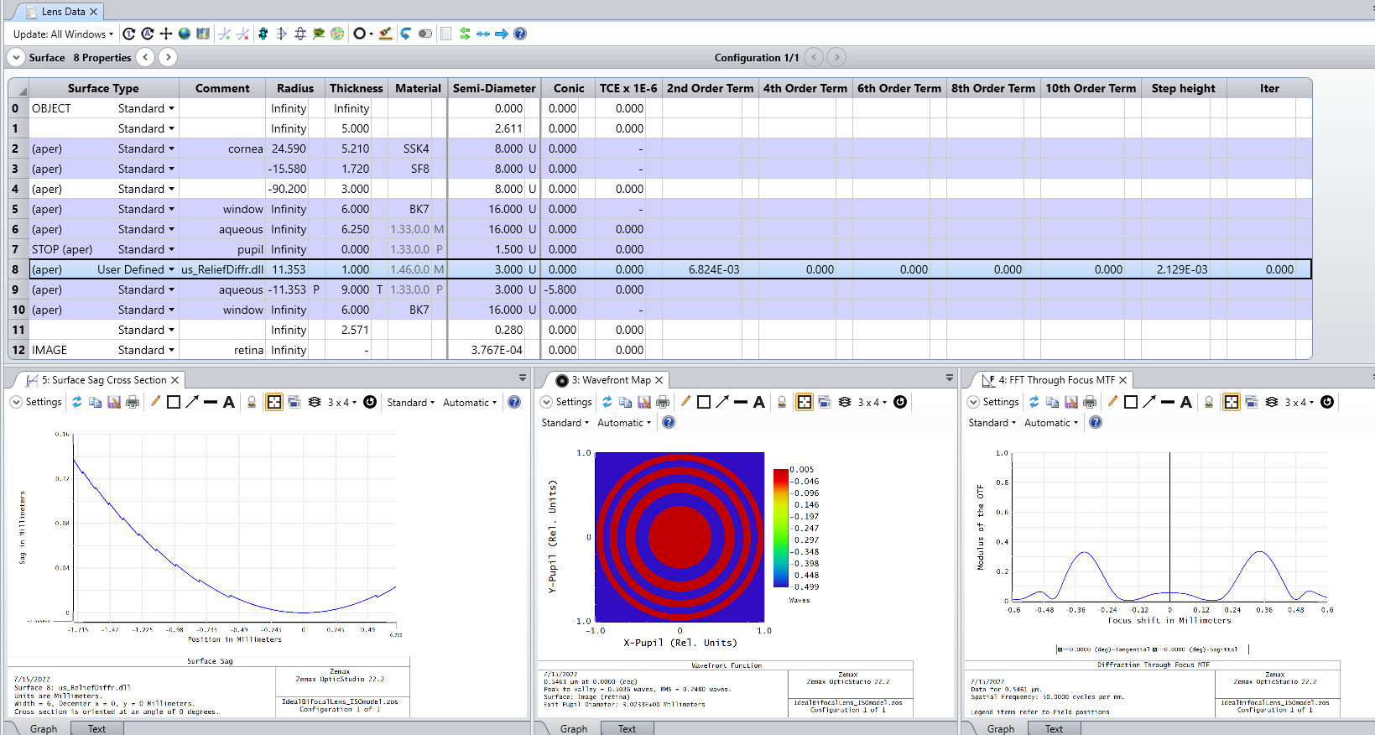

Overview
This User-Defined Surface DLL provides a realistic model of relief-type diffractive lenses based on zone-decomposition. Using zone-decomposition, diffraction into multiple orders can be accurately considered at once, and this method inherently accounts for wavelength dispersion and diffraction efficiency by modelling the actual shape of the diffractive element. Application examples include the creation of advanced intraocular lens models, where the different orders are designed to provide sharp vision for multiple viewing distances, thereby substituting accommodation of the natural crystalline lens.
Realistic modeling of relief-type diffractive intraocular lenses using User-Defined Surface DLLs – Knowledgebase (zemax.com)

Code Exchange Type
DLL Surface

Language
Cpp

Updates
Date | Version | OpticStudio version | Comment
20220715 | 1.0 | 22.2 | Creation

Instructions

Installation
To install the User-Defined Surface DLL, copy the .dll file to the {Zemax}\DLL\Surfaces folder. OpticStudio will have to be restarted to be able to use the DLL.

How to use
To use the DLL, open a sequential file in which you would like to use the relief-type diffractive surface. Change the surface type to User Defined and select the DLL.

